TRIBHUVAN UNIVERSITY

SAGARMATHA COLLEGE OF SCIENCE AND TECHNLOGY

SANEPA, LALITPUR



An Internship Proposal

On

Wind horse tours

at

Halftone Designs Pvt. Ltd.

Submitted By:

Urgen Sherpa (TU Exam Roll No. 3328/070)

Submitted To:

CSIT Department

Sagarmatha College of Science and Technology,

Sanepa, Lalitpur

February 4 , 2018

Table of Contents

List of Figures 2

Chapter 1: Introduction 3

1.1 Introduction of internship 3

1.2 Introduction of Company 3

1.2.1 Contact information 3

Chapter 2: Problem Statement 4

Chapter 3: Objectives 4

3.1 Internship Objectives 4

3.2 Specific Objectives 4

Chapter 4: Design and Implementation 5

4.1 Design 5

4.1.1 Site structure 7

4.2 Implementation tools 8

Chapter 5: Schedule 9

Chapter 6: Expected outcome 9

References 10

# List of Figures

Figure a-General architecture of PSD to html/css conversion 5

Figure b-Flowchart(a) 6

Figure c-Flowchart(b) 7

Figure d: Site structure 8

Figure e: Work scheduling 9

# Chapter 1: Introduction

## Introduction of internship

[1]An internship is an opportunity offered by an employer to potential employees, called interns, to work at a firm for a fixed, limited period of time. Interns are usually undergraduates or students, and most internships last for any length of time between one week and 12 months. Internships offer students a hands-on opportunity to work in their desired field. They learn how their course of study applies to the real world and build a valuable experience that makes them stronger candidates for jobs after graduation.

With the aim of acquiring hands-on training in the web designing and development, the author is doing internship at Halftone Designs Pvt. Ltd. as front end web developer.

## Introduction of Company

**Halftone Designs Pvt. Ltd. is one of the leading website design and development company of Nepal. This company was founded in 2011 and is located at Dillibazaar - Kathmandu, Nepal.**

**Halftone Designs mainly provide services regarding graphic designing, logo designing, website designing, web application development, Ecommerce solutions and web application maintenance. In addition to this, the company has also run training classes in the field of graphic designing, web designing, web application development, mobile application development etc.**

### ****1.2.1 Contact information****

* Halftone Designs Pvt. Ltd.
* Physical address: Abhiyan Marg, Kathmandu, Nepal
* Telephone: +977-1-4421754/+977-9851142573/+977-9803042573
* Website: http://htd.com.np/
* Email: info@htd.com.np
* Facebook: https://www.facebook.com/halftonedesigns/

# ****Chapter 2: Problem Statement****

Most of the people love to travel, trek and tour to new places and countries. For the purpose of trekking or tour, people used to contact the travelling and trekking company for getting authentic information, hassle-free trekking, sense of security, expert consultation etc. So, the trek and tour companies need reliable and effective medium to provide the detail information about their background, their provided services and more information regarding trek and tours. Furthermore, they also need an effective medium to provide consumer oriented services like checking the availability of trips and tours, reservation and payment gateways.

# Chapter 3: Objectives

## 3.1 Internship Objectives

The internship objectives are as follows:

* To experience and understand the work ethics, professional standard and technology used by an organization to achieve their goals.
* To get knowledge and experience in handling real world project.
* To become competent in order to land permanent job in related fields.

## 3.2 Specific Objectives

The specific objectives of the project to be done during internship are as follows:

* To bring the company profile, information and services they provide regarding trek and tours online.
* To facilitate people with the services of reservation, payment and checking the availability of trips, tours and treks online.

# Chapter 4: Design and Implementation

## 4.1 Design

[2]Web design is the process of creating [websites](https://techterms.com/definition/website). It encompasses several different aspects, including [webpage](https://techterms.com/definition/webpage) layout, content production, and graphic design. While the terms web design and [web development](https://techterms.com/definition/web_development) are often used interchangeably, web design is technically a subset of the broader category of web development.

First of all, before the actual development process, website template is designed by graphic designer using photoshop. Then the actual development process of photoshop template to website begins using html5 and css3. After that, javascript and jquery is used in order to add interactivity, animations and other effects to the static page.

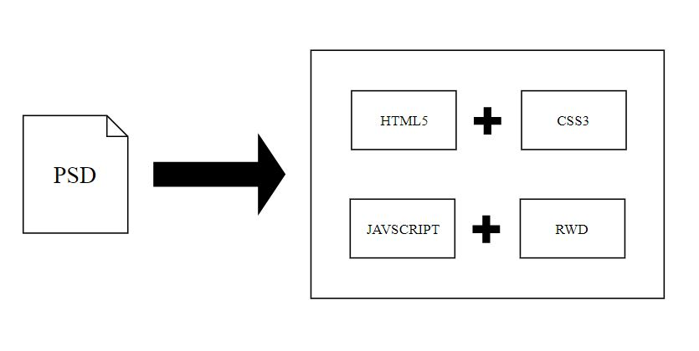

Figure a-General architecture of PSD to html/css conversion

The above figure shows the general architecture of PSD to html/css conversion. For the better understanding, the workflow of the process and steps taken in front end development are shown by the flowchart below:

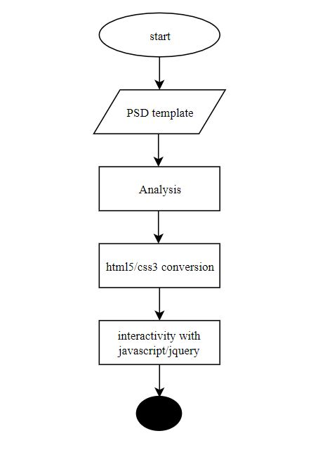

Figure b-Flowchart(a)

The above figure is the first part of the flowchart which shows the initial phase of converting PSD template to html5 and css3. After converting it to html and css, further process of adding animation, effects and interactivity is done through javascript and jquery.

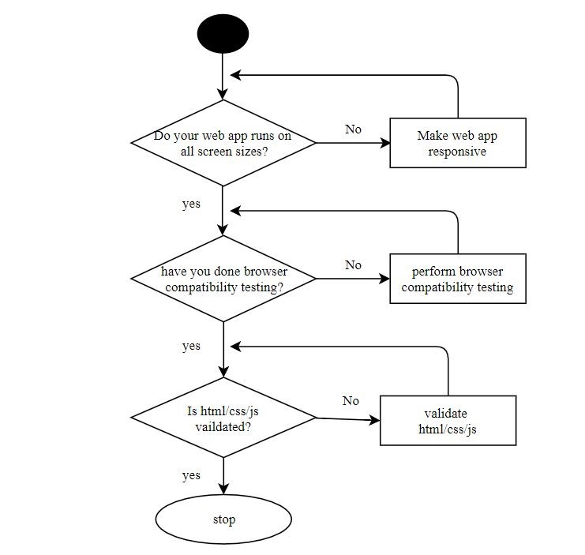

Figure c-Flowchart(b)

The above flowchart is the last part of the flowchart which shows the final phase of task of front end web developer. When the development or coding part of the user interface from PSD template is finished, then responsive design is added which should be compatible to all screen sizes. After that browser compatibility is tested and validation of html, css and javascript is done online.

### 4.1.1 Site structure

A clear, logical website structure aids navigation and orientation. The structure of the web page are as follows:

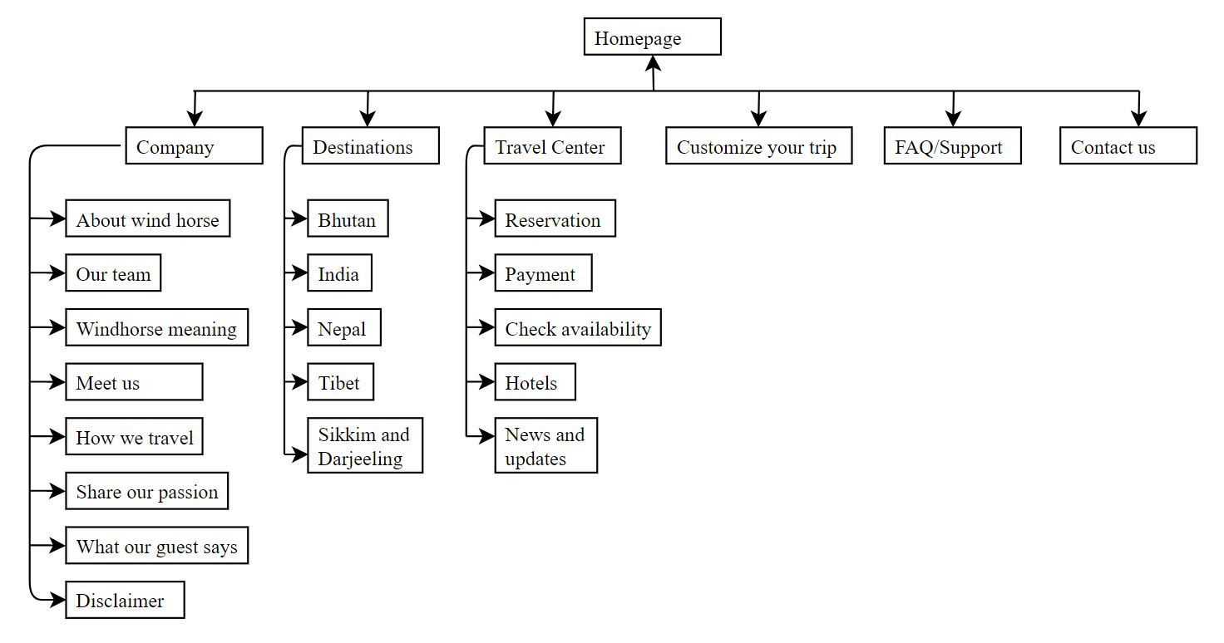

Figure d: Site structure

## 4.2 Implementation tools

The tools and technologies required in the project are as follows:

1. Photoshop cc 2017

Photoshop cc 2017 is used to measure the pixel value of the layout and to extract the image/logo.

1. Sublime text 3

Sublime text 3 is used as text editor to code html, css and javascript.

1. Html5

Html5 is used to create the basic structure and content of a webpage. It marks the contents up into different structural types, line paragraphs, blocks, lists, images, tables, forms, comment etc.

1. Css3

Css3 is used to design the contents of a webpage. It tells the browser how each type of element should be displayed, which may vary for different media (like screen, print or handheld device.

1. Javascript/jquery

Javascript is used to define the interactive elements of a webpage that helps to engage user. It tells the browser how to change the web page in response to events that happen (like clicking on something, or changing the value in a form input).

Jquery is javascript library. The purpose of jquery is to make javascript easier to use on website.

# Chapter 5: Schedule

The time schedule for the internship and the work that will be done during the internship are predicted as follows:

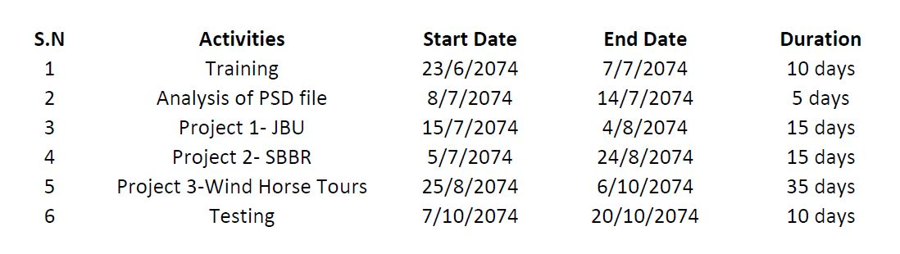

Figure e: Work scheduling

# Chapter 6: Expected outcome

The expected outcome of the project are as follows:

1. Live web application of Wind horse tours.
2. Services for tours and trek lovers to check availability of treks, reservation, online payment, customization of treks etc.

# References

|  |  |
| --- | --- |
| [1] | "1," 20 3 2017. [Online]. Available: https://www.wikijob.co.uk/content/internships/advice/what-internship. [Accessed 28 11 2017]. |
| [2] | P. Christensson, "1," Sharpened productions, 5 2 2013. [Online]. Available: https://techterms.com/definition/web_design. [Accessed 9 12 2017]. |